Submitted: 16 April 2023

Accepted: 25 August 2023

**Research Article**

**BIM Sociotechnology: Situational Awareness as a Strategy for Enhancing Collaboration in BIM-Enabled Education within the GCC Context[1]\***

**Raya Mahmoud Atour**

Graduate Assistant, Department of Architecture and Urban Planning, College of Engineering, Qatar University

ra2010351@qu.edu.qa

**Ahmad Mohammad Ahmad**

Assistant Professor, Department of Architecture and Urban Planning, College of Engineering, Qatar University

am.ahmad@qu.edu.qa

**Abstract**

The education and industry of architecture and engineering disciplines are being transformed by Building Information Modelling (BIM) through digitization. Recent literature shows that BIM is in reality 90% sociology and 10% technology, despite the perception that it is 90% technology and 10% sociology. Without social interventions within technological models, barriers and limitations that are evident in the social culture of an institution could result in being reflected in dead-ended technical and technological structures and solutions. For this, concepts of social sustainability and cultural resilience are promoted by proposing socio-technical solutions relying on the theoretical model of Situational Awareness (SA) as a cornerstone in this research. The investigation method on the link between BIM-enabled Education and SA is done through multiple interviews within the academic sector of multiple educational institutions within the Gulf Cooperation Council (GCC). The results of this study could design a preliminary framework for approaching technical solutions to social dilemmas and thus help in enhanced implementation and collaboration in BIM-enabled education in the GCC.

**Keywords:** Building Information Modelling (BIM); Sociotechnology; Higher Education; Collaboration; GCC region

**Cite this article as**: Atour, R.M. & Ahmad, A.M. "BIM Sociotechnology: Situational Awareness as a Strategy for Enhancing Collaboration in BIM-Enabled Education within the GCC Context." *Tajseer Journal*, Vol. 5, Issue 2 (2023).

https://doi.org/10.29117/tis.2023.0143

© 2023, Atour & Ahmad, licensee QU Press. This article is published under the terms of the Creative Commons Attribution-NonCommercial 4.0 International (CC BY-NC 4.0), which permits non-commercial use of the material, appropriate credit, and indication if changes in the material were made. You can copy and redistribute the material in any medium or format as well as remix, transform, and build upon the material, provided the original work is properly cited.

تاريخ الاستلام: 16 أبريل 2023

تاريخ القبول: 25 أغسطس 2023

**مقالة بحثية**

نمذجة معلومات البناء: الوعي بالواقع كاستراتيجية لتعزيز التعاون في مجال التعليم المدعوم بتقنية نمذجة معلومات البناء في منطقة دول مجلس التعاون الخليجي[2]*

**راية محمود عطور**

مساعد دراسات عليا، قسم الهندسة المعمارية، جامعة قطر، قطر

ra2010351@qu.edu.qa

**أحمد محمد أحمد**

أستاذ مساعد، قسم الهندسة المعمارية والتخطيط العمراني، جامعة قطر، قطر

am.ahmad@qu.edu.qa

# ملخص

حولت الرقمنة تعليم وصناعة الهندسة المعمارية والمدنية والبناء من خلال نمذجة معلومات البناء (BIM). تُظهر الدراسات والأدبيات الحديثة أن نمذجة معلومات البناء هي في حقيقتها مكونة من 90٪ علم اجتماع و10٪ علوم تقنية، على الرغم من التصور الرائج بأنها 90٪ تقنية و10٪ علم اجتماع. من دون وجود التدخلات الاجتماعية داخل النماذج التكنولوجية، يمكن أن تؤدي الحواجز والقيود التي تظهر في الثقافة الاجتماعية للمؤسسة إلى الانعكاس في الهياكل التقنية والتكنولوجية وبالتالي إلى حلول مسدودة. في هذه الدراسة، تم تعزيز مفاهيم الاستدامة الاجتماعية والمرونة الثقافية من خلال اقتراح حلول اجتماعية وتقنية تعتمد على الوعي والإدراك الموقفي كنموذج نظري وحجر زاوية. تعتمد هذه الدراسة على إجراء تحقيق لفهم الرابط بين التعليم الهندسي الخاص بنمذجة معلومات البناء (BIM) مع مفهوم الإدراك الموقفي، وذلك من خلال إجراء مقابلات متعددة داخل القطاع الأكاديمي للعديد من المؤسسات التعليمية داخل دول مجلس التعاون الخليجي. يمكن لنتائج هذه الدراسة أن تصمم إطارًا أوليًا لمقاربة الحلول التقنية للمعضلات الاجتماعية، وبالتالي تساعد في تعزيز من خطوات التنفيذ والتعاون في مجال التعليم الهندسي الخاص بنمذجة معلومات البناء (BIM) في دول مجلس التعاون الخليجي.

الكلمات المفتاحية: نمذجة معلومات البناء (BIM)، علم الاجتماع، التعليم العالي، تعاون، منطقة دول مجلس التعاون الخليجي

للاقتباس: عطور، راية محمود. وأحمد، محمد أحمد. «نمذجة معلومات البناء: الوعي بالواقع كاستراتيجية لتعزيز التعاون في مجال التعليم المدعوم بتقنية نمذجة معلومات البناء في منطقة دول مجلس التعاون الخليجي»، **مجلة تجسير،** المجلد الخامس، العدد 2 (2023)

https://doi.org/10.29117/tis.2023.0143

© 2023، عطور وأحمد، الجهة المرخص لها: دار نشر جامعة قطر. نُشرت هذه المقالة البحثية وفقًا لشروط Creative Commons Attribution-NonCommercial 4.0 International (CC BY-NC 4.0). تسمح هذه الرخصة بالاستخدام غير التجاري، وينبغي نسبة العمل إلى صاحبه، مع بيان أي تعديلات عليه. كما تتيح حرية نسخ، وتوزيع، ونقل العمل بأي شكل من الأشكال، أو بأية وسيلة، ومزجه وتحويله والبناء عليه، طالما يُنسب العمل الأصلي إلى المؤلف.

**1.** Introduction

The field of Architecture has been analysed through four distinct perspectives: the academic architect (academic approach), the craftsman-builder (crafts approach), the civil engineer (technological approach), and more recently, the social scientist (sociological approach).[3] This paradigm shift in understanding what architecture is and what the roles of architects are, is crucial to develop pedagogics that suit the current and future conceptions of the field. In this sense, designing the working and learning environments should reflect what this discipline needs, what type of interactions happen in it, and with whom, while not forgetting the umbrella of the cultural context where all this will fit in.

In this context, the studies show some educational institutions in the Gulf region had a unique approach in allocating certain university majors with prevailing social trends. For example, worldwide research shows that men are more prone than women to pursue degrees in STEM (science, technology, engineering, and mathematics).[4] Cultural beliefs tentatively support the findings of such studies. However, social factors do play a role in this indeed, as one study shows that the disparity in STEM participation between genders is comparatively reduced for those originating from countries where women exhibit a higher likelihood, in comparison to men, of pursuing STEM as a major.[5]

## 1.1 The Gulf Context

The context of the Gulf is unique, as women constitute a clear majority of undergraduate students in Kuwait, Bahrain, Qatar, and the UAE. At the same time, they account for almost half of the student body in Saudi Arabia and Oman.[6] This is also the case for postgraduate education studies, where there exists a gender difference across several Gulf Cooperation Council (GCC) nations, including Kuwait (with 76% female enrolment), UAE (with 66% female enrolment), and Qatar (with 63% female enrolment).[7] As for the field of Architecture, this study found that in a recent study targeting architecture students in various Jordanian universities, in a sample size of 615 students, 432 were female, and 185 were male. The researchers justify this by stating that gender imbalance and the higher proportion of female students are common features of architecture schools in Jordan.[8] However, in the interviews, one BIM expert and professional in Architectural Engineering education declared that this phenomenon is seen worldwide and is not a characteristic of a certain culture.

There is great importance in nurturing culture and imbedded values in a society and tailoring workplaces to fit them to achieve a state of resilience and thriving individuals. It is worth noting that most colleges in the GCC are gender-segregated.[9] With the presence of foreign accreditation bodies, the flexibility in changing the educational structure to what suits the local customs could be a challenge that needs to be addressed. The expansion of the Western curriculum and English language education in the GCC has often been supported by government accrediting bodies and accreditors, who are typically selected from the West to accredit the educational programs.[10] In this context, the curricula, learning styles, academic content, educational structures in the process of architectural education within this region are primarily based on Western models,[11] taking into account the presence of a competitive atmosphere among different states to have the highest, and most recent accreditations.

## 1.2. Gender Preferences in Education

According to university lecturers, the utilization of web-based instruction has been found to improve the learning outcomes of students in gender-segregated Higher Education Institutions (HEIs) in Saudi Arabia,[12] and in recent years, students were inclined to utilize digital resources and express content with the materials accessed.[13] Regarding the influence of gender on online learning and interaction preferences, a recent study targeting undergraduate students in Qatar showed that male students have more positive perceptions of instructor behaviour, assessment and evaluation, tools and technologies and were overall more satisfied.[14] As for learning autonomy, a study done in Jordan[15] shows no statistically significant differences between the male and female groups. Some researchers justify the difference in gender perceptions by considering female family members' multiple responsibilities in taking hold of house obligations. Additionally, a recent study[16] declared that the remote work arrangement had an adverse effect on the scientific output of several female faculty members as a result of heightened domestic responsibilities during the lockdown period, compounded by prevailing societal norms that discourage husbands from assuming an equitable share of family duties, particularly in Arabic nations.

## 1.3. Teaching Methodologies and the Covid-19 Experience

In architecture and design, the challenges associated with design problems are characterized by their lack of clear definition and structure, frequently resulting in disorientation and ambiguity among students.[17] Covid-19 pandemic's effect on education and distance learning was evident in pouring oil on the fire of uncertainty faced in the design education process. A recent Podcast was done at Qatar University in 2022, with an Arabic title that can be translated to: (A year on distant education: what’s next?) in Episode 3 of Season 2 of Research Wednesdays Series at Qatar University, featuring prominent faculty members at Qatar University. The podcast discussed the experiences and challenges faced during distance learning at Qatar University. The themes and weights of the concepts and their significance are shown in the figure below. The authors analysed the podcast manuscript by simultaneously listening, internally translating it from Arabic to English, and transcribing it in English and then conducting thematic coding via MAXQDA software. The translation quality is based on the author’s knowledge, as they listened to the podcast in Arabic and transcribed it in English based on their understanding of the both languages.

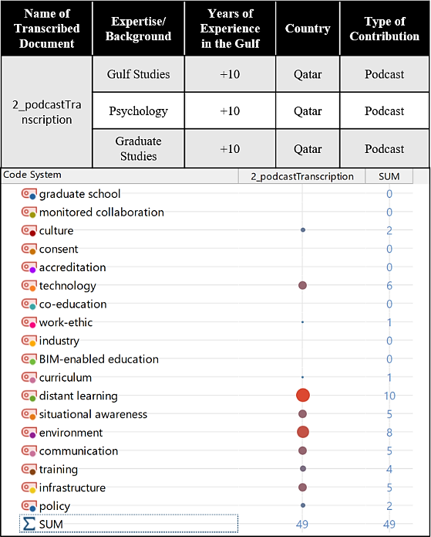

**Fig. 1:** Research Podcast Information and Discussed Themes

As of recent studies on this topic, the findings of one recent study in Qatar indicate that students pursuing STEM disciplines held unfavourable perceptions towards all the facets of online learning that were examined.[18] Additionally, in a study focusing on the satisfaction levels and perceptions of architecture students regarding online design studios during the COVID-19 lockdown in Jordanian universities, four dimensions regarding their learning experience were tested: Learning Engagement, Learning Behavior, Learning Quality, and Learning Autonomy. The dimension of learning engagement received the lowest satisfaction rating among the four dimensions, as reported by the students. The concept of learning engagement is composed of four distinct constructs that are shown in the figure below. The study shows peer learning and collaboration earned the lowest score.[19] Such categories can be used to develop future qualitative investigations with students and be part of the developing framework and its link to Situational Awareness (SA). In this regard,[20] advocate for higher education institutions to incorporate pandemic research into their respective contexts to customize Emergency Remote Teaching (ERT) to their individualized requirements.

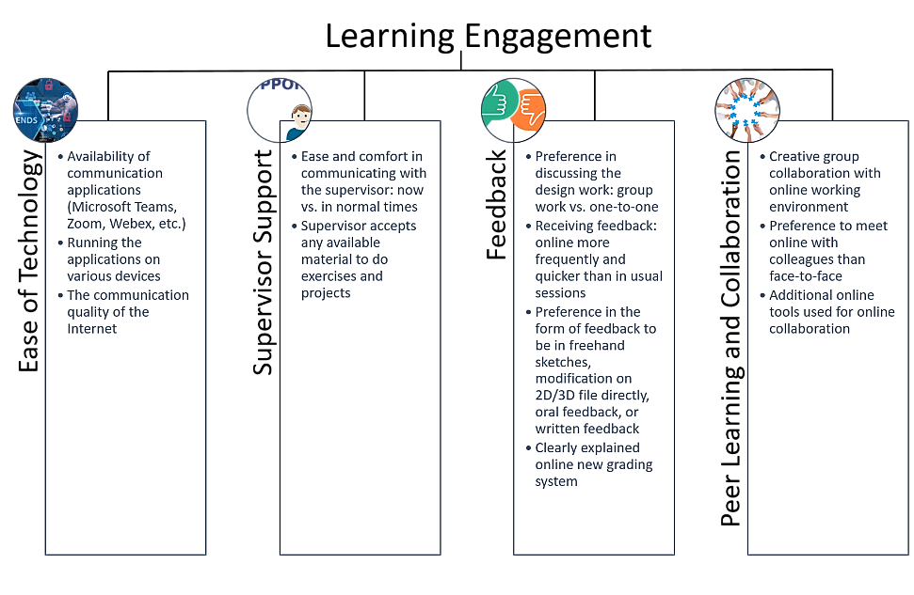

**Fig. 2:** Learning Engagement Categories

According to Chickering and Gamson,[21] engaging in collaborative activities with fellow students is a significant factor in achieving academic success. Furthermore, previous studies show that students contend that engaging with peers frequently enhances one's level of involvement in the learning process.[22] The authors assert that effective learning is characterized by collaboration and social interaction rather than competition and seclusion. It can be noted that the design studio fosters a sense of inclusivity among pupils, which exerts a noteworthy influence on the development of their architectural personas.[23] As for learning autonomy, student collaborations, whether for socialization or academic assistance, promote the development of learning autonomy by exposing students to a range of perspectives, thereby augmenting their self-awareness and capacity for self-evaluation and hence, facilitating collaboration and promoting the transfer of knowledge and skills is crucial in fostering self-reliance and transitioning from a tutor-centric to a student-centric learning environment.[24] Therefore, in emergencies, implementing synchronous virtual classrooms could be a feasible approach to maintaining valued interaction and collaboration among STEM learners.[25]

# 2. BIM and Education

The AEC industry is quickly adopting digital technology to create virtual environments for more efficient and effective communication and collaboration between architects, engineers, and contractors. These virtual environments can save time and resources while improving the final product's quality.[26] AEC education has developed with time and became affected by digitalization, resulting in a work process named Building Information Modelling (BIM), and although BIM involves using technology, it is not a software in itself but a methodology and approach of consistent collaboration with various parties working on a project to ensure synchronous information distribution and understanding by utilizing certain softwares that adapt and allow for the translation of the process to BIM’s methodology and sequence of work. Ensuring consistent and reliable data and information is crucial in facilitating the decision-making process in a BIM-facilitated project.[27]

There are four pillars of BIM, and three themes regarding BIM education, as shown in the figure below. Regarding these pillars and themes, many challenges are worthy of mentioning based on previous research done in this field. In a study done in Qatar on this topic,[28] Qatar-based professionals of Building Information Modelling (BIM) have identified an absence of BIM-focused curricula as a limiting factor for the Architecture, Engineering, and Construction (AEC) industry's ability to offer comprehensive training opportunities. The inadequacy of skilled personnel to offer a comprehensive BIM strategy complicates the previously mentioned deficiency.[29] With regards to learning and education, the results of a survey directed to Qatar-based professionals and BIM advocates[30] indicates that 50% of the participants perceived the maturity level of this category to be medium-low, while 25% of the participants identified it as low and another 25% identified it as a medium. In terms of Technology infrastructure, half of the participants indicated a medium level of maturity, while 25% reported a medium-low level. 12.5% of the participants reported a medium-high level of maturity, while the same percentage reported a high level of maturity.[31] Themes related to curriculum and student training are shown and addressed at the end of this research as part of the proposed preliminary framework.

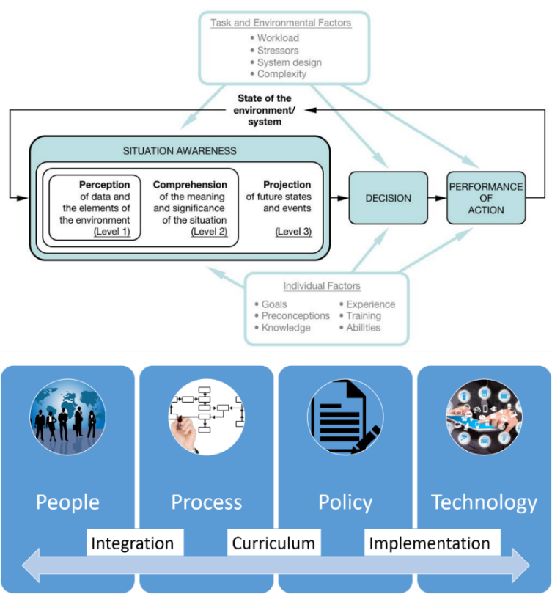

**Fig. 3: (**Top) Situation Awareness Model

Although BIM implementation can differ from one context to another, some factors remain constant especially in regions where BIM is early. One study addressing the root factors affecting BIM in the industry show that the primary factors impeding the implementation of Building Information Modelling (BIM) in developing countries, particularly within the Architecture, Engineering, and Construction (AEC) industry in Turkey are the challenges associated with the BIM transition process and insufficient support from management. The second set of fundamental factors that have a notable impact includes insufficient incentives, inadequate education on Building Information Modelling (BIM), predisposition towards BIM technology, and issues related to BIM-based software. Finally, the moderate impact of root factors was attributed to stakeholders' awareness and communication deficiencies.[32] As for BIM-based Education, the main challenges can be categorized into three themes: Curriculum, Collaboration/Integration, and Implementation.

The research gaps primarily revolve around inadequacies in the curriculum itself, the absence of a standardized approach to assessment and evaluation, and the lack of specific pedagogical techniques. Concerning integration/collaboration, the insufficiencies are centered on inadequate collaboration between academia and industry. As for implementation, the research gaps predominantly concern the lack of effective strategies and approaches for implementing (BIM) and deficiencies regarding its competencies.[33]

## 2.1. Situational Awareness

Situational Awareness, with its cognitive model is developed by Mica R. Endsley,[34] is in brief, “*The perception of environmental elements and events with respect to time or space. The comprehension of their meaning and the projection in their future status.”* The three levels of Situation Awareness can be linked to Lefebve’s theories on understanding the world through the three modes of spaces (spatial triad), the perceived, conceived, and lived space, as it is explained in his book The Production of Space.[35]

Situational awareness simply means making sense of context. When applying their ideas and theories, organisations must focus on the contextual environment's importance. It is a sensitive understanding and appreciation of the contextual situation. Maintaining situational awareness is crucial for effectively identifying the necessary actions to execute a task within a complex and dynamic environment. Especially when the significance of interest in fostering students' motivation to learn and its favorable influence on their active involvement in the learning process is much emphasized in literature.[36] The Architecture students are required to meet a significant cognitive demand by actively grappling with the inherent uncertainty in design problems.[37] Promoting motivation and joy has been found to foster learning engagement and ownership, ultimately resulting in the development of learning responsibility.[38]

## 2.2. The Case of QU and UAEU

An important note to address is whether the structure of an organization is based on a bottom-up approach (local culture) or rather a top-down approach (external impositions). Taking the case of comparing Qatar University (QU) with United Arab Emirates University (UAEU), the authors found that the distribution of university majors between different genders is different; QU allocates some majors to be exclusively for a certain gender type, while this is not the case with UAEU, and although some majors are offered to males and females in both universities, the classes are segregated and the courses are offered to female and male students in parallel tracks. However, in the case of UAEU, starting from 2023, this policy will no longer be effective; newly admitted students are to sign a consent form along their admission procedure acknowledging that they accept the co-education approach of the university. In such an example, we see how cultural views impact university policies and, later on, the larger educational community. Although, this is related to equity, the main focus is to achieve collaboration between the different engineering fields.

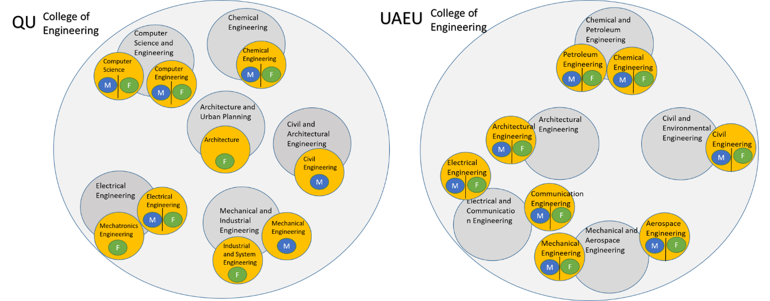

**Fig. 4:** Structure and Organization of University Majors in the Collage of Engineering in Qatar University and United Arab Emirates University

# 3. Methodology

The methods of this study largely depend on a qualitative approach where the patterns are sensed, observed, and categorised based on the interviews with the experts and people of beneficial experience. The sampling technique used to select the interview participants was based on the snowballing technique. The inclusion criteria for selecting the participants included faculty members and scholars with experience in inter-collaboration with students from different courses, departments, and colleges, especially in the GCC region. The experts addressed in this research topic are not limited to BIM experts but also to professionals in the AEC discipline who have experience in collaboration in virtual environments and challenges, especially in the GCC region. The data analysis of the interview data was done via a thematic analysis of interviews and recent official podcasts from higher education intuitions at the GCC region via MAXQDA qualitative analysis software. Noting that the interview language of communication was English, and all the transcripts were analysed via open coding approach to grasp themes relevant to our research topic and scope.

# 4. Findings

Based on the interview answers provided, of which details are shown in Figure 5 below, we find that the theme named ‘environment’ was the most mentioned topic and one of the most linked theme to the other categories observed. A key finding during the interviews was that many of the situations in the experience of collaboration and communication largely depend on policy. For example, in UAEU the effect of policy on the educational experience is very evident, as it was one of the most mentioned topics in the interview named (1_interviewTranscription), as it is shown in the number of occurrences of the code system elements in the figure below. Additionally, infrastructure plays a great role in facilitating any development in the institution, especially with the currently hot topic of distance learning, as shown in the code map below. What is also worth mentioning is how Situational Awareness was closely related to Work Ethic, Technology, and Distant Learning. This, therefore, reinforces the link between such concepts and how they must be addressed in research.

**Table 1:** Interviews Details Conducted in This Study

|  |  |  |  |  |
| --- | --- | --- | --- | --- |
| **Name of Transcribed Document** | **Expertise/ Background** | **Years of Experience in the Gulf** | **Country** | **Type of Contribution** |
| 1_interviewTranscription | BIM | +10 | UAE | Interview |
| 3_interviewTranscription | Sustainable Architecture and Design | +15 | KSA | Interview |
| 4_interviewTranscription | Computer Science | +5 | Qatar | Interview |

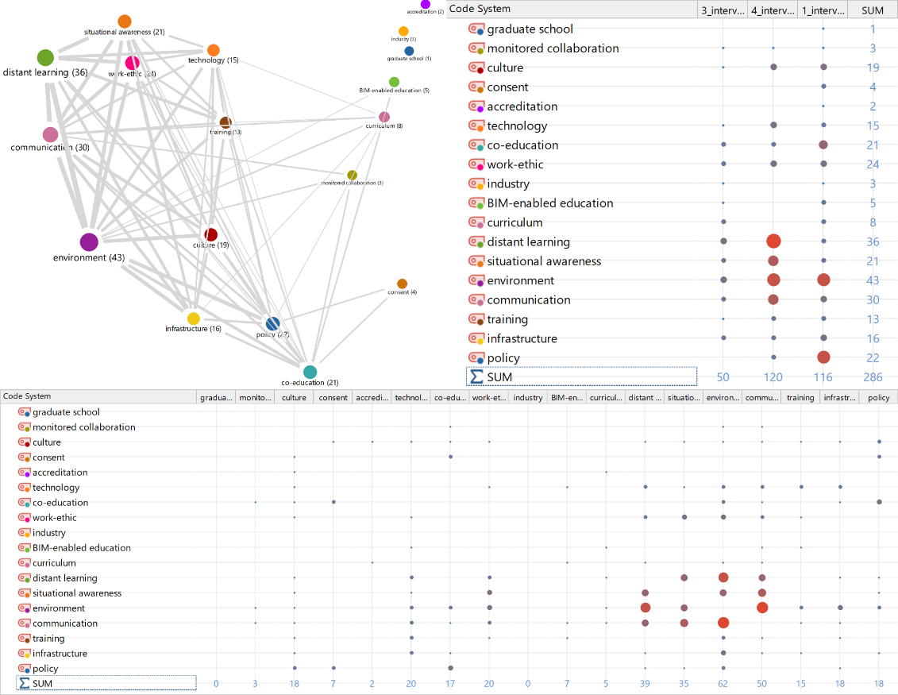

**Fig. 5:** (Top Left) Code Map: Analysed relations of codes: proximity of codes in the same document. (Top Right) Code Matrix Browser. (Bottom) Code relations browser

# 5. Discussion

To develop a preliminary framework, the themes deducted from the interviews are categorized and spread in the dimensions, pillars, and themes of BIM and BIM-Education. Using the three levels of Situational Awareness, the table below shows the justification for categorizing the themes into the following structure. In addition to the below-mentioned concepts, the researchers find that some concepts are missing like items focused on collaboration challenges practically and strategically. Such as:

* The requirements of each design team in their discipline.
* The accreditation requirement of different departments.
* The grading formats or percentages in the case of implementing BIM-enabled education within different departments in the college of Engineering.
* The class timing of collaboration between two different departments.
* The number of students from the department collaborating parties.
* Balancing small and larger number of students.
* The limitation of different gender collaboration, such as monitored collaboration, which is an act and concept that was deducted from the interviews of this study.

**Table 2:** Relationship and connections between BIM Pillars, BIM-Education Themes, Themes and Challenges observed from interviews and the Levels of Situational Awareness

|  |  |  |  |  |  |  |
| --- | --- | --- | --- | --- | --- | --- |
| BIM Pillars Affected | BIM in Education Themes | Affecting Parameters deducted from the Interviews | Levels of Situational Awareness relating to the affecting parameters | | | Justification |
| Perception | Comprehension | Projection |
| **Process**  Policy | Curriculum | Work ethic |  | **x** | **x** | The first step needed to insure a good work ethic includes ensuring that the participant is aware of the situation they are in by conducting periodic quizzes. Additionally, prospecting the outcomes of high work ethic makes the student/professional more responsible of their deliverables. |
| Interdisciplinary Courses within the Engineering College |  | **x** | **x** | Curriculum is done to prepare students for the future and therefore mainly acts in projecting the needed topics and areas of future need. However, understanding the current situation and approaching solutions that solve them is what is missing in the GCC education and therefore the curriculum needs to take into consideration the current methods of organizing colleges in the GCC and consider the gender-segregation challenge in designing the curriculum of such colleges. |
| Communication |  | **x** |  | Communication is categorized as part of BIM’s Integration theme however it is also part of the process since the essence of BIM is about collaboration and continuous synchronization of efforts into a holistic whole at any project. |
| **People**  Process | Integration | Industry |  |  | **x** | Industry was largely discussed in the context of prospecting the situation post-graduation. |
| Co-education |  |  | **x** | Co-education was discussed as a needed procedure that must be taken in order to prepare students for the industry environment and reality. |
| Distant learning |  | **x** |  | Distant learning’s most important dimension to be currently focused on is its current reality and how students could actually feel and develop awareness to the virtual environment. |
| Environment |  | **x** |  | As in Distant Learning, environment largely is related to be aware to the instant reality the student/professional is experiencing. |
| Training | **x** |  |  | Training is needed in the early stages of any complex communication happening as the student/professional needs to identify the challenges observed before comprehending them and then projecting solutions for them. |
| Communication | **x** |  |  | Communication needs to be done on early stages of a situational awareness model as it parallel relates to identifying the current reality. |
| **Policy**  Technology | Implementation | Gender segregation and monitored collaboration |  |  | **x** | Policies in any institution must study past situations and prospective upcoming challenges. |
| BIM-enabled education |  | **x** |  | BIM-enabled education is in its early stages in the GCC region and is therefore in need of comprehension to identify the current and context-specific challenges in order to tailor-fit solutions that are applicable and relevant. |
| Infrastructure | **x** |  |  | Any change in policy, curriculum, or environment must begin with the existing infrastructure and what it can offer. |

# 6. Conclusion

One of the key concepts of situational awareness is the distinction between a person (or system) and the environment. Therefore, to deeply understand it, we must understand users’ experiences and identify the challenges observed in the current educational environment. The GCC region's educational institutions are well-equipped with high-speed internet and online platforms like Microsoft Teams, WebEx, and Blackboard, according to the authors, who discovered that the GCC region's educational institutions primarily have a relatively efficient technological infrastructure. As a result, infrastructure in the GCC region is not a problem. The research limitation of this study is that it is investigating a topic in its infancy stage and therefore must rely on unstructured data to come up with nearly-correct conclusions. Knowing that for any discourse about improving postgraduate education on a national or regional scale, precise and dependable data must be considered.[39] Making informed decisions about educational policies and planning, enhancing the graduate student experience, and improving undergraduate curricula in the Gulf are significantly hampered by the lack of organized information and data retention, as was found in another study on education in the GCC, particularly in Qatar.[40] Future challenges that will be looked into, to further this research include including the voice and opinions of students studying in STEM majors in the GCC generally and in Qatar specifically to learn about their types of challenges and whether they differ from what was gathered and analysed in this study, which was primarily based on the study sample from experienced individuals in the intermediate field from various diverse environments. The recommendations of this study include creating educational programs of an interdisciplinary nature between disciplines and departments inside and outside the colleges, and spreading the culture of intra-research and activating it in the field of research.

**References**

Abdulmumin, A., B Bolo,. K.Y., Haddary, G.M. & Chindo, P.G.. "Bim Education Ontology: Towards a Research Agenda for Non-Industrialised Economies," In: Laryea, S. and Essah, E. (Eds) *Proceedings of the West Africa Built Environment Research (WABER) Conference 2021* (South Africa: WABER, 2021), pp. 333-350.

Ahmad, A., Aliyu, A., & Mohammed, N. "Understanding People Dimension Towards Bim Culture Change in Consultancies." *Solid State Technology* Vol. 63 (2020).

Al Maani, D., & Roberts, A. *Developing Autonomous and Responsible Learners: A Hidden Perspective in the Design Studio.* Conference: European Association for Architectural Education, Zagreb, Croatia (2020).

Albalawi, M. "Critical Factors Related to the Implementation of Web-Based Instruction by Higher-Education Faculty at Three Universities in the Kingdom of Saudi Arabia." PhD, The University of West Florida, 2007.

Aldén, L., & Neuman, E. "Culture and the Gender Gap in Choice of Major: An Analysis Using Sibling Comparisons." Vol. 201 (2022).

Alnusairat, S., Al Maani, D. & Al-Jokhadar, A. "Architecture Students’ Satisfaction with and Perceptions of Online Design Studios During Covid-19 Lockdown: The Case of Jordan Universities." *International Journal of Architectural Research Archnet-IJAR* 15 (2020). <https://doi.org/10.1108/ARCH-09-2020-0195>.

Badry, F., & Willoughby, J. *Higher Education Revolutions in the Gulf: Globalization and Institutional Viability.* New York: Routledge, 2016.

Chickering, A.W., & Gamson, Z.F.. "Seven Principles for Good Practice in Undergraduate Education." *AAHE bulletin*  (1987).

Cross, N. *Design Thinking: Understanding How Designers Think and Work.* Oxford: Berg, 2011. doi:10.5040/9781474293884.

Elrefaey, O.H. "Impact of Digital Technology on Creating Virtual Environment in the Aec Industry." Construction Management Masters Thesis, American University of Sharjah, 2023.

Endsley, M.R. "Toward a Theory of Situation Awareness in Dynamic Systems." *Human Factors,* Vol. 37, No. 1 (1995). <https://doi.org/10.1518/001872095779049543>.

Kahu, E., Nelson, K., & Picton, C. "Student Interest as a Key Driver of Engagement for First Year Students." *Student Success,* Vol. 8, No. 2 (2017) <https://doi.org/10.5204/ssj.v8i2.379>.

Lawson, B. *How Designers Think – the Design Process Demystified*. Cambridge: Cambridge University Press, 2006.

Lefebvre, H. *La Production de l'espace (The Production of Space)*. Paris, Anthropos, 1974.

Leuze, K., and Strauß, S. "Lohnungleichheiten Zwischen Akademikerinnen Und Akademikern: Der Einfluss Von Fachlicher Spezialisierung, Frauendominierten Fächern Und Beruflicher Segregation / Wage Inequality between Male and Female University Graduates: The Influence of Occupational Specialization, Female-Dominated Subjects and Occupational Segregation." *Zeitschrift für Soziologie, Vol.* 38, No. 4 (2009). <https://doi.org/10.1515/zfsoz-2009-0401>.

Nelson, H., & Stolterman, E. *The Design Way: Intentional Change in an Unpredictable World.* Cambridge, MIT Press, 2012. doi:10.7551/mitpress/9188.001.0001.

Newsome, M. "Graduate Research Experience in the Arab Gulf: The Case in Qatar." In *Social Change in the Gulf Region*, edited by Md Mizanur Rahman and Amr Al-Azm, Springer, 2023.

Newsome, M.L., Pina, A.A., Mollazehi, M., Al-Ali, K., & Al-Shaboul, Y. "The Effect of Gender and Stem/Non-Stem Disciplines on Remote Learning: A National Study of Undergraduates in Qatar." *The Electronic Journal of e-Learning,* Vol. 20, No. 4 (2022). <https://academic-publishing.org/index.php/ejel/article/view/2262>.

Philipp, J. "Gendered University Major Choice: The Role of Intergenerational Transmission." Vol. 36, No. 2 (2022).

Prabhakaran, A., Mahamadu, A., Mahdjoubi, L., Andric, J., Manu, P., & Mzyece, D. "An Investigation into Macro Bim Maturity and Its Impacts: A Comparison of Qatar and the United Kingdom." *Architectural Engineering and Design Management,* Vol. 17, No. 5-6 (2021). <https://doi.org/10.1080/17452007.2021.1923454>.

Rahim, N., Zakaria, S., Romeli, N., Ishak, N., & Losavanh, S. "Application of Building Information Modeling toward Social Sustainability." *IOP Conference Series: Earth and Environmental Science* Vol. 920, No. 012007 (2021). <https://doi.org/10.1088/1755-1315/920/1/012007>.

Salama, A. "Decolonizing Architectural Knowledge: Situating Middle Eastern Pedagogies in a Globalizing World (Critical Studies in Architecture of the Middle East)." In *Islamic Architecture Today and Tomorrow: (Re)Defining the Field*, edited by Mohammad Gharipour and Daniel E. Coslett, Bristol: Intellect, 2022.

Tan, S., & Ayalp, G.G. "Root Factors Limiting Bim Implementation in Developing Countries: Sampling the Turkish Aec Industry." *Open House International,* Vol. 47, No. 4 ( June 2022). <https://doi.org/10.1108/OHI-12-2021-0273>.

Thompson, J. "Becoming an Architect: Narratives of Architectural Education." PhD dissertation, University of Washington, 2016.

Zabaniotou, A. "The Covid-19 Lockdowns Brought to Light the Challenges That Women Face in Mediterranean Universities." Global Transitions, Vol. 3 (2021).

**Appendix: Interview Questions**

**GCC Context**

* Tell us your experience on educating in the Gulf – what makes it special (politics, climate, culture, economy)?
* What do you think the future of BIM will be in GCC? Is the challenge of implementation based on training professionals (people), enhancing the industry (process), investing in higher technology (technology) or updating mandates (policy)?

**Online Learning and Collaboration Dimensions**

* Online learning and communication experience
* Do you think it can be used as a method for flexible communication?

**Work Ethics – Individual Factors affecting Situational Awareness (SA)**

* Do you think online communication and collaboration would need us to focus on areas of sense of responsibility, maturity, and work ethics of the students?
* Do you think the use of Situational Awareness model would help in creating a virtual work experience with a higher sense of authority?
* What type of action is needed to promote clear Goals, Preconceptions, Knowledge, Experience, Training, Abilities of students in virtual interactions?

**Workload and Stressors – Task and Environmental Factors affecting Situational Awareness (SA)**

* Did you find gender separation in higher education to be limiting collaboration in AEC education?

**Situational Awareness**

* What do you think is the main challenge in collaboration in GCC AEC education? Is it Perception, Comprehension, or Projection?
* Do you think cultural factors could hinder the perception, comprehension, or projection of the environment, and thus affect its effective communication in it?

1. * Submitted for: The Annual Conference of Ibn Khaldon Center on Interdisciplinary Research (September 30th- October 1st, 2023).
2. * قُدم في: مؤتمر مركز ابن خلدون السنوي للتجسير (30 سبتمبر- 1 أكتوبر 2023).
3. - Ashraf Salama, "Decolonizing Architectural Knowledge: Situating Middle Eastern Pedagogies in a Globalizing World (Critical Studies in Architecture of the Middle East)," In Mohammad Gharipour and Daniel E. Coslett, Islamic Architecture Today and Tomorrow: (Re)Defining the Field, (Bristol: Intellect, 2022), p. 223.
4. - Kathrin Leuze and Susanne Strauß, "Lohnungleichheiten zwischen Akademikerinnen und Akademikern: Der Einfluss von fachlicher Spezialisierung, frauendominierten Fächern und beruflicher Segregation / Wage Inequality between Male and Female University Graduates: The Influence of Occupational Specialization, Female-Dominated Subjects and Occupational Segregation," *Zeitschrift für Soziologie,* Vol. 38, No. 4 (2009), pp. 262-281; Lina Aldén and Emma Neuman, "Culture and the gender gap in choice of major: An analysis using sibling comparisons," *Journal of Economic Behavior & Organization*, Vol. 201 (2022), pp. 346-373; Julia Philipp, "Gendered University Major Choice: The Role of Intergenerational Transmission," *Journal of Population Economics*, Vol. 36, No. 2 (2022), pp. 1049-1097.
5. - Aldén and Neuman, "Culture and the gender gap in choice of major," pp. 346-373.
6. - Fatima Badry and John Willoughby, Higher education revolutions in the Gulf: globalization and institutional viability (New York: Routledge, 2016).
7. - Mary Newsome, "Graduate Research Experience in the Arab Gulf: The Case in Qatar," In Md Mizanur Rahman and Amr Al-Azm, Social Change in the Gulf Region, (Springer, 2023), pp. 127-139.
8. - Saba Alnusairat, Duaa Al Maani, and Amer Al-Jokhadar, "Architecture students’ satisfaction with and perceptions of online design studios during COVID-19 lockdown: The case of Jordan universities," *International* *Journal* *of Architectural Research Archnet-IJAR*, Vol. 15 (2020).
9. - Badry and Willoughby, *Higher education revolutions in the Gulf: globalization and institutional viability.*
10. - Ibid.
11. - Salama, "Decolonizing Architectural Knowledge."
12. - Mohammed Albalawi, "Critical Factors Related to the Implementation of Web-Based Instruction by Higher-Education Faculty at Three Universities in the Kingdom of Saudi Arabia" (PhD Dissertation, The University of West Florida, 2007).
13. - Alnusairat, Al Maani, and Al-Jokhadar, "Architecture students’ satisfaction with and perceptions of online design studios during COVID-19 lockdown."
14. - Mary L. Newsome et al., "The Effect of Gender and STEM/non-STEM Disciplines on Remote Learning: A National Study of Undergraduates in Qatar," *The Electronic Journal of e-Learning,* Vol. 20, No. 4 (2022), pp. 360-373.
15. - Duaa Al Maani and Andrew Roberts, *Developing Autonomous and Responsible Learners: A Hidden Perspective in The Design Studio*. Conference: European Association for Architectural Education, Zagreb, Croatia (2020), pp. 294-311.
16. - Anastasia Zabaniotou, "The COVID-19 lockdowns brought to light the challenges that women face in Mediterranean universities," *Global Transitions*, Vol. 3, (2021), pp. 119-125.
17. - Alnusairat, Al Maani, and Al-Jokhadar, "Architecture students’ satisfaction with and perceptions of online design studios during COVID-19 lockdown."
18. - Newsome et al., "The Effect of Gender and STEM/non-STEM Disciplines on Remote Learning," pp. 360-373.
19. - Alnusairat, Al Maani, and Al-Jokhadar, "Architecture students’ satisfaction with and perceptions of online design studios during COVID-19 lockdown."
20. - Newsome et al., "The Effect of Gender and STEM/non-STEM Disciplines on Remote Learning," pp. 360-373.
21. - Arthur W. Chickering and Zelda F. Gamson, "Seven principles for good practice in undergraduate education," *AAHE bulletin* (1987).
22. - Al Maani and Roberts, *Developing Autonomous and Responsible Learners*.
23. - James Thompson, "Becoming an Architect: Narratives of Architectural Education" (PhD dissertation University of Washington, 2016).
24. - Al Maani and Roberts, *Developing Autonomous and Responsible Learners.*
25. - Newsome et al., "The Effect of Gender and STEM/non-STEM Disciplines on Remote Learning," pp. 360-373.
26. - Omar H. Elrefaey, "Impact of Digital Technology on Creating Virtual Environment in the AEC Industry" (Construction Management Masters Thesis, American University of Sharjah, 2023).
27. - N. Rahim et al., "Application of Building Information Modeling toward Social Sustainability," *IOP Conference Series: Earth and Environmental Science*, Vol. 920, No. 012007 (2021), pp. 1-7.
28. - Abhinesh Prabhakaran et al., "An investigation into macro BIM maturity and its impacts: a comparison of Qatar and the United Kingdom," *Architectural Engineering and Design Management*, Vol. 17, No. 5-6 (2021), pp. 496-515.
29. - Ibid.
30. - Ibid.
31. - Ibid.
32. - Seda Tan and Gülden Gümüşburun Ayalp, "Root factors limiting BIM implementation in developing countries: sampling the Turkish AEC industry," *Open House International*, Vol. 47 (June 2022), pp. 732-762.
33. - Abdulazeez Abdulmumin et al., "Bim Education Ontology: Towards a Research Agenda for Non-Industrialised Economies," In: Laryea, S. and Essah, E. (Eds) *Proceedings of the West Africa Built Environment Research (WABER) Conference 2021* (South Africa: WABER, 2021), pp. 333-350.
34. - Mica R. Endsley, "Toward a Theory of Situation Awareness in Dynamic Systems," *Human Factors*, Vol. 37, No. 1 (1995), pp. 32-64 .
35. - Henri Lefebvre, *La production de l'espace (The Production of Space)*, (Paris: Anthropos, 1974).
36. - Ella Kahu, Karen Nelson, and Catherine Picton, "Student interest as a key driver of engagement for first year students," *Student Success*, Vol. 8, No. 2 (July 2017), pp. 55-66; Al Maani and Roberts, *Developing Autonomous and Responsible Learners: A Hidden Perspective in The Design Studio*.
37. - Bryan Lawson, *How Designers Think – The Design Process Demystified* (Cambridge: Cambridge University Press, 2006); Nigel Cross, *Design Thinking: Understanding How Designers Think and Work* (Oxford: Berg, 2011); Harold Nelson and Erik Stolterman, *The Design Way: Intentional Change in an Unpredictable World* (Cambridge: MIT Press, 2012); Al Maani and Roberts, *Developing Autonomous and Responsible Learners: A Hidden Perspective in The Design Studio*.
38. - Al Maani and Roberts, Ibid.
39. - Newsome, "Graduate Research Experience in the Arab Gulf: The Case in Qatar," pp. 127-139.
40. - Ibid.